PROVIDENCE ARBOURS HOMEOWNERS ASSOCIATION, INC.
Policy Resolution #5: Policy Resolution Relating to Mailboxes
Enacted: May xx, 2016 Effective: May xx, 2016
WHEREAS, Article VI, Section 2 of the Declaration of Covenants, Conditions, and Restrictions for Providence Arbours Homeowners Association requires Owners to obtain written consent of the Board of Directors or the Architectural Control Committee (a.k.a. "ACC"), as appropriate, for certain changes to Lots and Structures;
WHEREAS, the Board of Directors deems it necessary to establish guidelines and procedures for Owners wishing to make changes to their homes;
Now therefore be it resolved that the following be adopted, and shall supersede all previous resolutions pertaining to these same matters.
All Providence Arbours mailboxes are of a uniform model and black in color. Please see below.
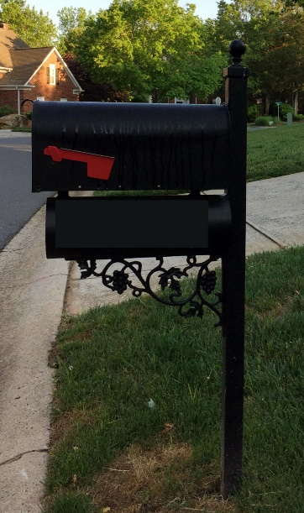 | For repair or replacement:  Ornamental Specialties Inc  3488 Gribble Rd  Matthews, NC 28104  (704) 821-9154  http://ornamentalspecialties.com/

APPROVED:
___________________________ Date _________________
President

____________________________ Date _________________
Secretary

